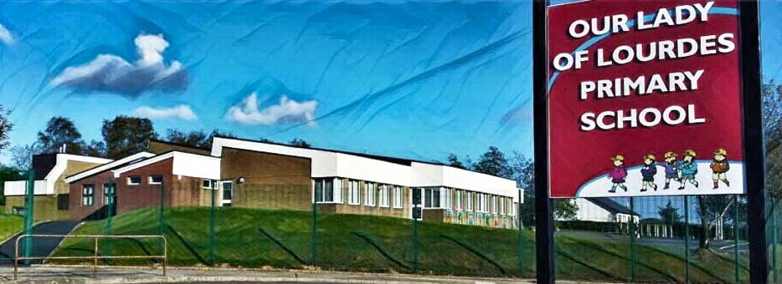Our Lady of Lourdes Greencastle

279 Crockanboy Road ● Omagh ● BT79 7QP

Telephone: (028) 8164 8732 Fax: (028) 8164 8265

Principal: Mrs D Mc Cann B.Ed, PQH(NI)

E-mail: [dmccann396@c2kni.net](mailto:dmccann396@c2kni.net)

Twitter: @GreencastlePS

Website: [https://www.ourladyoflourdespsgreencastle.com/](https://mail.c2kschools.net/owa/redir.aspx?C=KWw3w989R7HPo2JB5Liis5HScsdaVdn5woCIcIBA3NV_oFLKPa3WCA..&URL=https%3a%2f%2fwww.ourladyoflourdespsgreencastle.com%2f)



5 November 2020

Dear Parent/Guardian

We are delighted to welcome all the children back to school on Monday and we hope you all had an enjoyable Halloween break.

To date our school has remained a safe environment for children, staff and visitors. I would like to thank you for your support and commitment shown to school procedures.

To ensure the continued safety of our school community it is important that you do not send your child to school;

If they are displaying symptoms such as a new continuous cough, a high temperature or a loss of taste or smell.

1. If anyone in the household is waiting for the result of a Covid-19 test.
2. If anyone in the household has had a positive test and is self-isolating.
3. If you have been notified that your child has been in close contact with someone who has received a positive Covid-19 test.
4. I would also encourage parents to wear face masks while dropping off or collecting children from school and to continue to follow social distancing regulations at the school gate to ensure the health and well- being of all our school community.

**Key Dates to remember:**

Friday 13 November – Creative Writing (closing date)

Monday 16 November – School photographer

Monday 16 November - Wear odd socks day

Monday 16-20 November - Anti Bullying week

Tuesday 17 November – Flu vaccine

Monday 23-27 November – Maths Week( P1-P7)

Monday 30 November – Parent /Teacher meetings (school closed)

**Stars of the Week**

**Well done our pupils who worked hard in class and achieved certificates this week**

Cara Rose Keenan P1/2

Paidi Bradley P1/2

Cathair Conway P2/3

Erin Campbell P2/3

Erin Warnock P4/5

Anna Mae Mc Elduff P4/5

Aine Mc Glinchey P5/6

Phelim Tracey P5/6

Leah Fox P6/7

Conor Molloy P6/7

**Parent Teacher Meetings**

Our Parent Teacher Meetings will take place on Monday 30th November. The Department of Education have advised against face to face meetings. To ensure the safety of parents and staff, the meetings will be held via telephone. The calls will last 10 minutes. Please ensure that we have up to date telephone contact details for you.

Please do not hesitate to contact me if you have any queries.

Yours Sincerely,

Diane Mc Cann