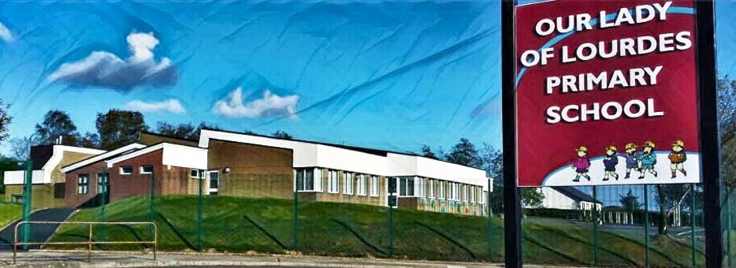Our Lady of Lourdes Greencastle

279 Crockanboy Road ● Omagh ● BT79 7QP

Telephone: (028) 8164 8732 Fax: (028) 8164 8265

Principal: Mrs D Mc Cann B.Ed, PQH(NI)

E-mail: [dmccann396@c2kni.net](mailto:dmccann396@c2kni.net)

Twitter: @GreencastlePS

Website: [https://www.ourladyoflourdespsgreencastle.com/](https://mail.c2kschools.net/owa/redir.aspx?C=KWw3w989R7HPo2JB5Liis5HScsdaVdn5woCIcIBA3NV_oFLKPa3WCA..&URL=https%3a%2f%2fwww.ourladyoflourdespsgreencastle.com%2f)



**Prizes for Christmas Raffle**

Gym Voucher

Food Hamper

Bodhran

Beauty Hamper

Yankee Candle Scenterpiece

Prosecco & Flute Hamper

Fitness Tracker & Activity Tracker Watch

Relax & Pamper Treat

Food hamper

Christmas puzzle (1000 piece)

Beauty Hamper

Baylis & Harding Lotion Set

Drinks Hamper

Yankee Candle Set

M & S Biscuits, Box Sweets

Set of Books & O’Neills Football

Bottle wine, Shloer & Christmas book.