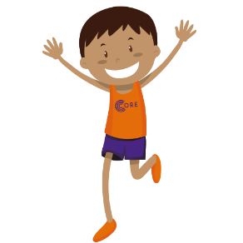
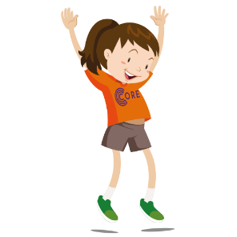
CORE NI PE and Wellbeing Portal
Video Links

Foundation

Games
Body Part Call Out https://vimeo.com/451766576/a19dca9a1b
TV Channel - https://vimeo.com/468458459/2c7ad2a2cf
Morning Routine - https://vimeo.com/474340994/9f57eb13d1

Athletics
Jumping and landing - https://vimeo.com/453437144/8c963b5f5f

Gymnastics
4 point balance - https://vimeo.com/455593464/8b47ab5983
The world around us - https://vimeo.com/467495119/ab259bff6e

Dance
ABC’s part 1 - https://vimeo.com/459972949/01b3d9eb53
ABC’s part 2 - https://vimeo.com/460054452/4cb57f3bc0

Key Stage 1

Games
Body Part Call Out https://vimeo.com/451766576/a19dca9a1b
TV Channel - https://vimeo.com/468458459/2c7ad2a2cf

Athletics
Throwing & Catching - https://vimeo.com/451655104/ad7adb3570
Jumping and landing - https://vimeo.com/453437144/8c963b5f5f

Gymnastics
Gymnastics 2 points - https://vimeo.com/455622495/dcc78d3435

Dance
Hip hop part 1 - https://vimeo.com/459974606/2fdf5dd9ba
Hip Hop part 2 - https://vimeo.com/460094551/440aa12934

Key Stage 2

Games
Strength Movements - https://vimeo.com/476833819/d941665283

Athletics
Running Technique - https://vimeo.com/453419441/5ee122fa39

Gymnastics
Gymnastics 2 points - https://vimeo.com/455622495/dcc78d3435

Dance
Robot part 1 - https://vimeo.com/460079801/f034b14925
Robot part 2 - https://vimeo.com/460085982/75736d06e0

Wellbeing

Breathing
Mindfullness breathing - https://vimeo.com/459131872/e7e169ab71
Hand breathing - https://vimeo.com/474340343/a175b7b0d0

Story time with Annette - Foundation
Have you filled your bucket today? - https://vimeo.com/489589364/7e8fe75af7
The invisible string - https://vimeo.com/489586840/18995f1ed9

