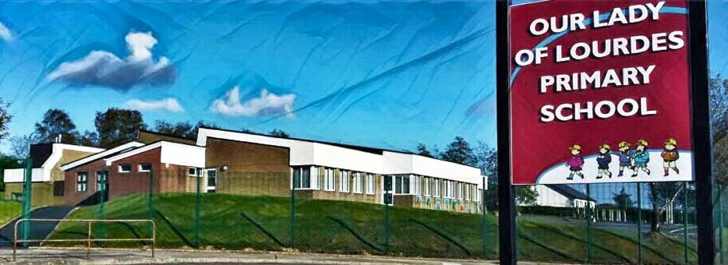Our Lady of Lourdes Greencastle

279 Crockanboy Road ● Omagh ● BT79 7QP

Telephone: (028) 8164 8732 Fax: (028) 8164 8265

Principal: Mrs D Mc Cann B.Ed, PQH(NI)

E-mail: [dmccann396@c2kni.net](mailto:dmccann396@c2kni.net)

Twitter: @GreencastlePS

Website: [https://www.ourladyoflourdespsgreencastle.com/](https://mail.c2kschools.net/owa/redir.aspx?C=KWw3w989R7HPo2JB5Liis5HScsdaVdn5woCIcIBA3NV_oFLKPa3WCA..&URL=https%3a%2f%2fwww.ourladyoflourdespsgreencastle.com%2f)



**Provisional Dates:**

Confirmation: Saturday 5th June at 11.00am.

First Confessions: Thursday 10th June at 7.00pm.

First Communion: Saturday 25th September at 11.00am.