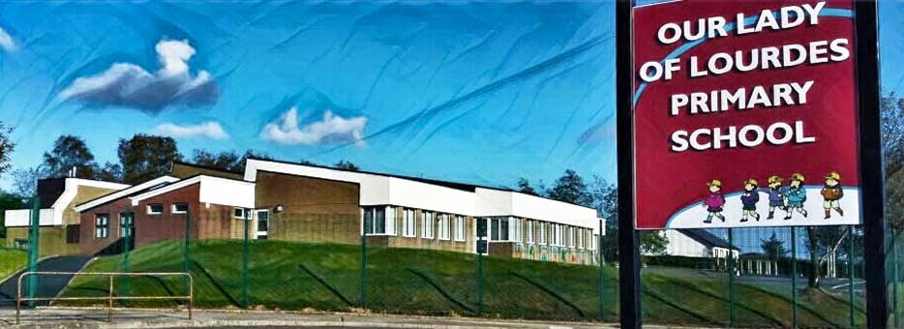Our Lady of Lourdes Greencastle

279 Crockanboy Road ● Omagh ● BT79 7QP

Telephone: (028) 8164 8732 Fax: (028) 8164 8265

Principal: Mrs D Mc Cann B.Ed, PQH(NI)

E-mail: [dmccann396@c2kni.net](mailto:dmccann396@c2kni.net)

Twitter: @GreencastlePS

Website: [https://www.ourladyoflourdespsgreencastle.com/](https://mail.c2kschools.net/owa/redir.aspx?C=KWw3w989R7HPo2JB5Liis5HScsdaVdn5woCIcIBA3NV_oFLKPa3WCA..&URL=https%3a%2f%2fwww.ourladyoflourdespsgreencastle.com%2f)



16th December 2020

Dear Parents,

***Christmas Holidays***

Please note the change to Christmas holidays dates. School will now close on Friday 18th December at 12 noon. There will be no school dinners provided on that day. **School transport will be provided in the morning but not at 12 noon. Children have to be picked up at this time.**

School will re-open on 5th January as planned. Our P.3 pupils will stay in school until 3.00pm each day. This will commence on 5th January.

As we are closing earlier than planned we will be changing our St. Patrick’s Day holidays to one day instead of three days. School will be closed on Wednesday 17th March. Reopens Thursday 18th March.

***Christmas Draw winners, please see separate list.***

A massive thank you to all parents who donated prizes for our raffle and to all who bought tickets. We are extremely grateful to everyone who made our draw so successful.

We raised £700, this money will help purchase resources for our school.

We also received £800 donated in lieu of Christmas presents for staff. We are overwhelmed by the generosity of parents and we will be using the money to update our class reading books.

***Santa visit***

Santa Claus made a surprise visit to our school. He arrived in his camper van and treated the pupils to some singing and left sweets for everyone. Thank you to Santa for making sure all the children in Our Lady of Lourdes have a special and magical Christmas.

***Christmas Card Competition***

Greencastle GAA Winners are:

P6/7 Shea Donnelly, Clodagh Brogan

P5/6 Emma Conway, Aoife Slane

P4/5 Caoimhe Coyle

P2/3 Cillian Tuohey, Ronan McAleer, Erin Campbell

P1/2 Colleen McLaughlin, Paidi Brogan

***School Admissions 2021-2022***

School admission for pupils hoping to start Year 1 in September 2021 can do so by filling in the on-line form on EA website.

Yours sincerely

Diane McCann