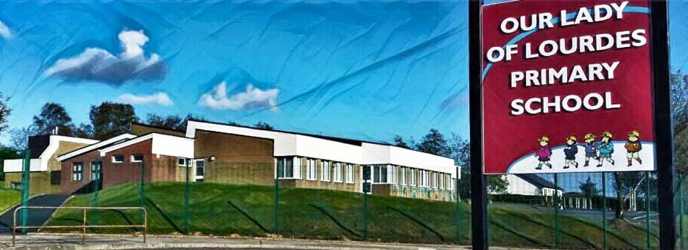Our Lady of Lourdes Greencastle

279 Crockanboy Road ● Omagh ● BT79 7QP

Telephone: (028) 8164 8732 Fax: (028) 8164 8265

Principal: Mrs D Mc Cann B.Ed, PQH(NI)

E-mail: [dmccann396@c2kni.net](mailto:dmccann396@c2kni.net)

Twitter: @GreencastlePS

Website: [https://www.ourladyoflourdespsgreencastle.com/](https://mail.c2kschools.net/owa/redir.aspx?C=KWw3w989R7HPo2JB5Liis5HScsdaVdn5woCIcIBA3NV_oFLKPa3WCA..&URL=https%3a%2f%2fwww.ourladyoflourdespsgreencastle.com%2f)



Dear Parents

I hope you all had a safe and relaxing Christmas.

As you are no doubt aware the Minister of Education announced recently that schools will not re-open until 11th January.

As a result of this I need to inform you of how this will impact our school community. Staff will be in school on Monday 4th January to prepare work for remote learning for next week. Then from Tuesday 5th January remote learning will take place for all children using Seesaw. From Tuesday we will be open to accommodate any children who require supervision. They too will be taught remotely under supervision as there will be no face to face teaching next week.

The school will remain open on these dates for vulnerable children and the children of key workers as directed by the Minister. If your child falls into either of these categories, please contact me by email no later than noon on Monday 4th Jan to allow us to plan ahead for the week - [dmccann396@c2kni.net](mailto:dmccann396@c2kni.net).

This is not how we hoped to start our new school term but as a staff we will continue to support you and your children in every way we can.

Regards

Diane Mc Cann