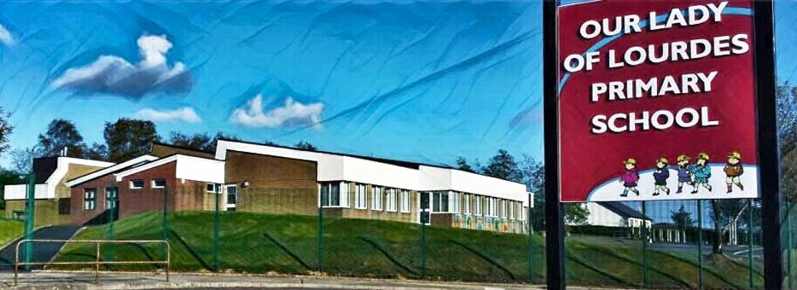Our Lady of Lourdes Greencastle

279 Crockanboy Road ● Omagh ● BT79 7QP

Telephone: (028) 8164 8732 Fax: (028) 8164 8265

Principal: Mrs D Mc Cann B.Ed, PQH(NI)

E-mail: [dmccann396@c2kni.net](mailto:dmccann396@c2kni.net)

Twitter: @GreencastlePS

Website: [https://www.ourladyoflourdespsgreencastle.com/](https://mail.c2kschools.net/owa/redir.aspx?C=KWw3w989R7HPo2JB5Liis5HScsdaVdn5woCIcIBA3NV_oFLKPa3WCA..&URL=https%3a%2f%2fwww.ourladyoflourdespsgreencastle.com%2f)



8 January 2021

**Update: Re-opening of school for Term 2**

Dear Parents,

Following my message to you on 2nd January I want to update you further. As you are aware the Education Minister has announced a further lockdown period for all schools. Schools are due to re-open after the planned mid - term holidays (this is subject to change).

Schools are to remain open for children in the vulnerable category and for the children of Keyworkers ***who have no other form of childcare available to them. It is important to note that the supervised learning provision can only be used as a last resort, otherwise, we may be forced to use criteria to ensure numbers do not go over a sustainable level. Protection and safety of our children from Covid 19 is our top priority.***

Remote Learning:

Remote learning will take place via the Seesaw platform. Your child’s teacher will explain the tasks that are to be completed.

**P1-P3 Daily Tasks:**

1.Numeracy

2.Literacy

3.Other (RE, WAU,ART.PE)

**P4 –P7 Daily Tasks:**

1.Numeracy

2.Literacy

3.Other (RE, WAU, ART, PE)

4.Spelling

5.Accelerated Reader

P.E –See link for Core N.I posted on Seesaw.

We do not expect all work to be completed, as we understand the pressures of home life at this difficult time.

Teachers will submit explanatory videos to support your child when necessary. You will appreciate the volume of work returning to the teachers via Seesaw daily. Please allow time for teachers to comment/mark on your child’s work.

Supervised Learning:

School will be open from 9am -3pm for those booked to attend. Children must wear their school uniform and bring a packed lunch. Children will access the Seesaw platform from within the school to complete the activities set by their teacher. They will be supervised by Classroom Assistants.

Remote Learning Packs:

P.1-P.7 children can call into school from Friday 2pm-3pm, Monday 10am-2pm to collect home Learning packs which contain hard copies of work which will be posted on Seesaw as well as exercise books/paper etc needed to complete work.

Many thanks for your continued patience and support at this time. We as a staff will do our utmost to support you and your children during this period of remote learning.

Kind regards

Mrs Diane McCann