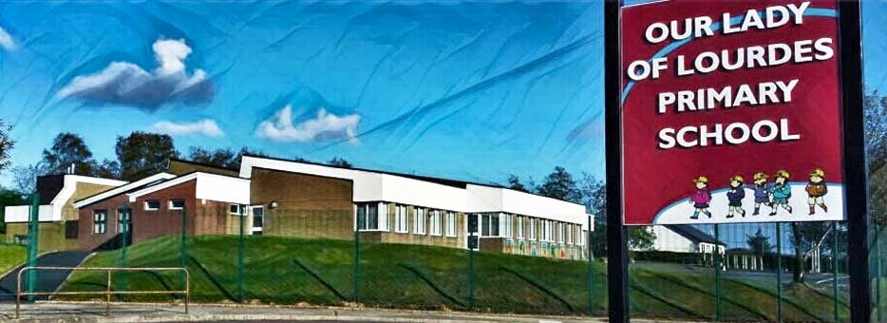Our Lady of Lourdes Greencastle

279 Crockanboy Road ● Omagh ● BT79 7QP

Telephone: (028) 8164 8732 Fax: (028) 8164 8265

Principal: Mrs D Mc Cann B.Ed, PQH(NI)

E-mail: [dmccann396@c2kni.net](mailto:dmccann396@c2kni.net)

Twitter: @GreencastlePS

Website: [https://www.ourladyoflourdespsgreencastle.com/](https://mail.c2kschools.net/owa/redir.aspx?C=KWw3w989R7HPo2JB5Liis5HScsdaVdn5woCIcIBA3NV_oFLKPa3WCA..&URL=https%3a%2f%2fwww.ourladyoflourdespsgreencastle.com%2f)



14th January 2021

Dear Parent/Guardian

I hope you are keeping safe and well and that your child is enjoying remote learning via Seesaw. The teachers will schedule teaching and learning activities on a daily basis and we would encourage all parents to ensure your child is engaging and submitting their online work.

I would ask parents/guardians and pupils to read and complete the remote learning agreements on the following form:

Remote Learning Parent Agreement: <https://forms.office.com/Pages/ResponsePage.aspx?id=-yeCOETeDkaBkAVAK4mNqCA00UM3501NiVugHNVucbJUNEdaR0JNM0lCVjZCM1VZMExPNllSRTc2OS4u>

Remote Learning Pupil Agreement- <https://forms.office.com/Pages/ResponsePage.aspx?id=-yeCOETeDkaBkAVAK4mNqCA00UM3501NiVugHNVucbJUOTJRUlQxNFpWMVZOMkFIRVY2TTNCTFdIQi4u>

The Education Minister has asked schools to assist key workers who are maintaining essential public services and who have exhausted all other options of childcare. Therefore, our school will be open for any vulnerable children and will accommodate children of key workers who meet the criteria set by DE.

In order to stop the spread of Covid-19 through our school community we want to limit the attendance of staff and pupils at school.

If you are a key worker and meet the criteria or have a vulnerable child and have exhausted all other alternatives for child care provision, the school will make arrangements to provide supervised learning for your children. If you would like to apply for a place for your child, I would be grateful if you could complete the survey on the following link:

<https://forms.office.com/Pages/ResponsePage.aspx?id=-yeCOETeDkaBkAVAK4mNqCA00UM3501NiVugHNVucbJUNk5QTlgyQVRLMzRHSDNMWVdZMlo3MTQ0Qy4u>

and submit before 3pm Friday 15th January 2021

This will help us plan for the provision of supervised learning for Vulnerable children and key workers. Following receipt of any requests, I will contact parents to make further arrangements.

Kind Regards

Mrs Diane Mc Cann