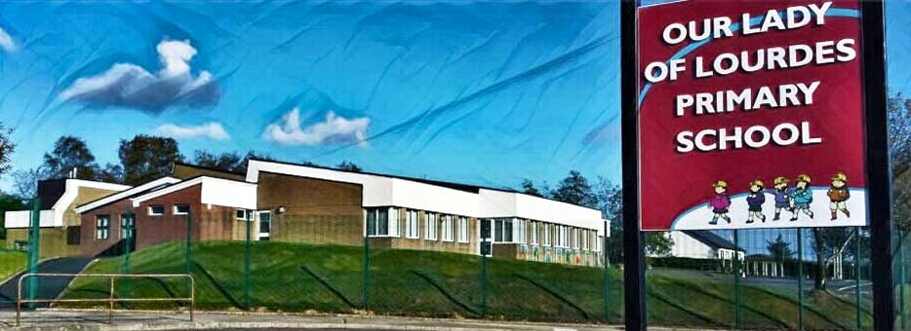Our Lady of Lourdes Greencastle

279 Crockanboy Road ● Omagh ● BT79 7QP

Telephone: (028) 8164 8732 Fax: (028) 8164 8265

Principal: Mrs D Mc Cann B.Ed, PQH(NI)

E-mail: [dmccann396@c2kni.net](mailto:dmccann396@c2kni.net)

Twitter: @GreencastlePS

Website: [https://www.ourladyoflourdespsgreencastle.com/](https://mail.c2kschools.net/owa/redir.aspx?C=KWw3w989R7HPo2JB5Liis5HScsdaVdn5woCIcIBA3NV_oFLKPa3WCA..&URL=https%3a%2f%2fwww.ourladyoflourdespsgreencastle.com%2f)



3rd March 2021

**Return to School (P.1-P.3)**

Primary 1-3 children will return to school on Monday 8th March for full-time face to face teaching.

Normal drop-off and collection times will be in operation.

Drop-off from 8.45-9.00am with collection at 1.50pm for P.1; 2.00pm for P.2 and 2.50pm for P.3.

We await clarification from Department of Education on whether they will return to remote learning on the 22nd March or remain in school until Easter.

**School Dinners P1-P3 Classes**

School dinners will be available for P1-P3 children from next Monday 8th March. Please see the menu attached. Dinners are not available to the children attending the supervised learning provision at this time.

**P.7 Post Primary Transfer Procedure**

Parents of P.7 pupils must complete the online application process at some stage before Tuesday 16th March at 4pm.

**St Patrick’s Day Closure**

The school will be closed on Wednesday 17th March. Re-open to P1-P3 pupils and Key Workers/Vulnerable children on Thursday 18th March.