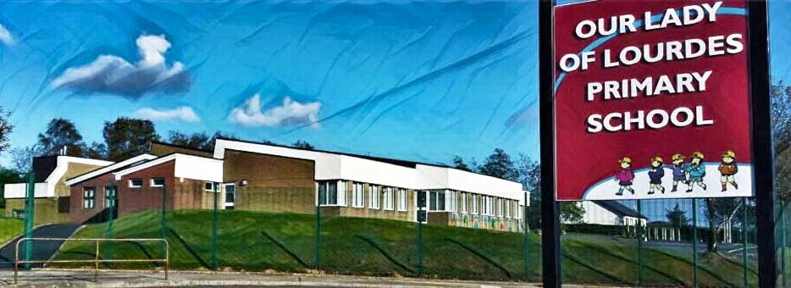Our Lady of Lourdes Greencastle

279 Crockanboy Road ● Omagh ● BT79 7QP

Telephone: (028) 8164 8732 Fax: (028) 8164 8265

Principal: Mrs D Mc Cann B.Ed, PQH(NI)

E-mail: [dmccann396@c2kni.net](mailto:dmccann396@c2kni.net)

Twitter: @GreencastlePS

Website: [https://www.ourladyoflourdespsgreencastle.com/](https://mail.c2kschools.net/owa/redir.aspx?C=KWw3w989R7HPo2JB5Liis5HScsdaVdn5woCIcIBA3NV_oFLKPa3WCA..&URL=https%3a%2f%2fwww.ourladyoflourdespsgreencastle.com%2f)



18 March 2021

Dear Parents,

You will be aware of that we can open for all pupils on Monday 22nd March. We are delighted to be able to open and are very much looking forward to welcoming your children back to school!

Due to the very short notice, all remote learning for P.4-P.7 pupils is suspended on Friday, to allow the staff time to prepare for next week.

**Parents of Key Workers/Vulnerable children –you may send your child in only if you have absolutely no other option for this one day. School will close early on Friday (12.30pm) for Key Worker’s children. This is to allow for deep cleaning of classrooms in preparation for Monday**.

The arrangements for Primary 4-7 children returning to school on Monday 22nd March with the Primary1-3 children who returned to school on 8th March will be as follows:

**School will open at 8.30** and children in Mrs Conway’s, Mrs Devlin’s and Mr Mc Shane’s classes should enter school from the playground into their classrooms.

Children in Ms Treacy’s and Mrs Mc Cann’s classes should enter school through the main door.

**All children must wear full uniform** as normal, and please ensure that all items are labelled.

**School Dinners**

School dinners will operate as normal with each class eating together in their separate bubbles. Please remember to send dinner money in on the Monday of each week in a marked envelope.

**School Bags & Lunchboxes**

Children should not bring a bag to school. We ask that lunch is packed in a plastic lunchbox or lunch bag.

**Homework**

Written homework will start after the Easter holidays.

**School Books**

Please check at home and return all school books. We rely upon all school text books including library books being returned as these are used for Accelerated Reading.

**Enhanced Focus on Safety Protocols**

As a school community, we must re-focus our attention on the most up to date advice and guidance from the PHA. It is very important that we focus on our hand hygiene at all times and that we do our utmost to ensure that social distancing is maintained. We ask that parents are mindful of this when dropping off and collecting children from school and that you continue to refrain from gathering in groups or breaking the 2 metre social distancing rule at the school gates.

If your child is feeling unwell, please do not send them to school until they are feeling better. If you or your child are showing Covid 19 symptoms, do not send them to school and contact the PHA helpline (119) to arrange a test. We ask that you liaise closely with the school even if your child’s symptoms are not Covid 19 related.

Yours sincerely

Diane McCann