Fan the Flame 2020
Reflective Journal for Year Seven and Sixth Class Pupils

“The Beatitudes Reveal the Path to True Happiness…they Always Lead to Joy”
(Pope Francis)

Introduction
As you come towards the end of your time in primary school, we hope this journal will help you to think about those years, the people you have met, the friends you have made, the gifts and talents you have developed and the teachers and staff, who have helped you to become the wonderful young person you are.
Most importantly we hope that this will allow you to see that your friend Jesus was and is with you every step of the way. He has been with you in the good days and the difficult days. He is with you now when you are at home, instead of being in school celebrating together the end of a very important time in your lives.
But endings can also be beginnings and this ending means you are ready for another step on your journey. You will move to new schools, with new people to help you. You may go to a school with some of the friends you have now, and you will also make new friends, learn new things and develop even more gifts and talents.
And your friend Jesus will still be with you, helping you to find the path to true happiness, to become the wonderful person God has created you to become. And the Holy Spirit will be there too, as your helper, your guide just as Jesus promised.
Before you start the journal say a short prayer asking God to help you to remember and to be grateful for your time in primary school. Take time as you complete this journal-there’s no need to rush.
We were hoping to see you all at the Fan the Flame Mass for Year 7/6th Class in Celtic Park on 4th June. We can’t do that at the minute. So we invite you, with your family, to a special Mass on the 4th June at 10am via the webcam at Saint Eugene’s Cathedral http://www.steugenescathedral.com/webcam.html This Mass will be said by Bishop McKeown, for you.
We thank God for the gift all the boys and girls in Year Seven and Sixth Class are to this diocese and ask God’s blessing on you as you prepare to leave your school and start on another stage of your journey, with Jesus your friend!

“Fan into Flame the Gift that is Yours” (Saint Paul)
God has made you in his image and likeness. (Genesis 1:27)

Draw a picture of yourself!

Name: _____________________________________________

“I have called you by your name, you are mine’ (Isaiah: 43:1)

My birthday is _________________________

The Church I was baptised in was ________________________

by Father _____________________

Draw your family!

Jesus said, “Let the little children come to me” (Matthew 19:14)
Name of School ______________________________________
My favorite thing about school is ___________________________
________________________________________________________
________________________________________________________
________________________________________________________
My School-Write the names of your friends and teachers below!

My favourite place in the school building is __________________________

Draw a picture of you and your friends in this place

Think of words to describe the type of Person you have grown to become over the last 7/8 years at Primary School?
____________________________________________________________________________________________________________________________________________________________________________________________________________________________________________
___________________________________________________________

The saddest or hardest day of my time in school was___________________ ___________________________________________________________
___________________________________________________________
The happiest day of my time in school was ______________________________________________________________________________________________________________________
___________________________________________________________
Moving On…

I’m leaving Primary School
What will I miss most?

- ______________________________________________________________________________________________________________

- ______________________________________________________________________________________________________________

...New Beginnings

I’m looking forward to my new school-making new friends and trying new subjects.
I’m a bit nervous about moving to a new place. What if I don’t fit in?

What am I looking forward to?
- _____________________________________________

- _____________________________________________

My Friendship with Jesus “I call you friends, because I have told you everything I heard from my Father” (John 15:15)
During my years in _________________________ Primary School I have spent time getting to know more about God. I have come to know God the Father through becoming a close friend of Jesus. Through my Baptism, I am a friend and a brother or sister of Jesus
There have been some occasions when I met Jesus in a very special way when I celebrated the sacraments with my family, my school and my parish. The things I remember most about celebrating these sacraments are ____________________________________________________________________________________________________________________________________________________________________________________________________________________________________________
My Friendship with Jesus grows through Prayer
“Lord, teach us to pray” (Luke 11:1)

My special friend’s name is: _________________________________

In each of the bubbles below, write a word to describe your friend

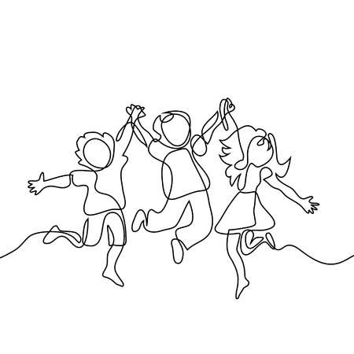
Think about what you would like to tell your friend

1. ____________________________________________

2. ____________________________________________

3. ____________________________________________
In each of the bubbles below, write a word to describe Jesus

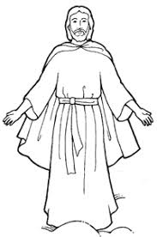

What would you like to say to Jesus
1. __________________________________________________ __________________________________________________

2. __________________________________________________ __________________________________________________

3. __________________________________________________ __________________________________________________

You have just written a little prayer from your own to Jesus.
There are 5 main types of prayer: 1. Prayer of Adoration – “What you do is amazing” 2. Prayer of Petition – “We need you help to….” 3. Prayer of intercession – “Please help people in need” 4. Prayer of Thanksgiving – “Thank You” 5. Prayer of Praise – “We love you”

God’s Perfect Plan for Me-True Happiness!
“God will show you the path of life, the fullness of joy in my presence” (Psalm16)
God has a perfect plan for everyone. He has a perfect plan for you. In order to live out that plan, it’s important to stay very close to Jesus and be guided everyday by the Holy Spirit. Jesus gave his special friends a way of living the perfect plan God has for each person when he gave them the Beatitudes. The sacraments you have received are a gift from God and will help you to live out the Beatitudes each day.

The Latin word for ‘blessed’ is ‘beatus’. Beatitudo means ‘blessedness’ or ‘happiness’ Sometimes when we see the Beatitudes written they use the word ‘Blessed’ or ‘Happy’.
What does that mean? The Beatitudes are a gift given to all of us, not just long ago to Jesus’ friends. They are as Pope Francis says a ‘path to true happiness’

Jesus wants all people to be happy. It doesn’t matter what you look like, where you live, what you have. Jesus is the way to be truly happy. The Beatitudes are his promises of happiness-happiness here on earth and in heaven.
When we follow the Beatitudes, we are being like Jesus. We are God’s love in the world today. Pope Francis says we should learn then off not just in our minds but in our hearts too!
Read the Gospel Story of ‘The Sermon on the Mount’ below from the Gospel of Matthew, Chapter 5
Seeing the crowds, he went onto the mountain. And he sat down and was joined by his disciples. Then he began to speak. This is what he taught them:
How happy are the poor in spirit: theirs is the kingdom of Heaven. Happy are the gentle: they shall have the earth for their heritage Happy are those who mourn: they shall be comforted. Happy are those who hunger and thirst for what is right: they shall be satisfied. Happy the merciful: they shall have mercy shown them. Happy are the pure in heart: they shall see God. Happy the peacemakers: they shall be called sons of God. Happy are those who are persecuted in the cause of right: theirs is the kingdom of Heaven. Happy are you when people abuse you and persecute you and speak all kinds of calumny against you on my account. Rejoice and be glad, for your reward will be great in heaven; this is how they persecuted the prophets before you.

On Thursday 4th June at 10am Watch the Fan the Flame Mass for all Year7/6th Class Pupils on Saint Eugene’s Cathedral Webcam with your Family. http://www.steugenescathedral.com/webcam.html
Quiet Time
After the Mass write down three things that Bishop McKeown said about the Beatitudes and what you can do to be God’s love in the world.
____________________________________________________________________________________________________________________________________________________________________________________________________________________________________________
____________________________________________________________________________________________________________________________________________________________________________________________________________________________________________
What do the Beatitudes mean for me? What can I do to be truly happy? How can I help others to be truly happy?

Prayer to Jesus
Jesus be with me, Jesus be within me,
Jesus be behind me, Jesus be before me,
Jesus be beside me, Jesus comfort and restore me,
Jesus be beneath me, Jesus be above me,
Jesus be in quiet, Jesus be in danger, Jesus be in hearts of all who love me,
Jesus be in mouth of friend and stranger.

