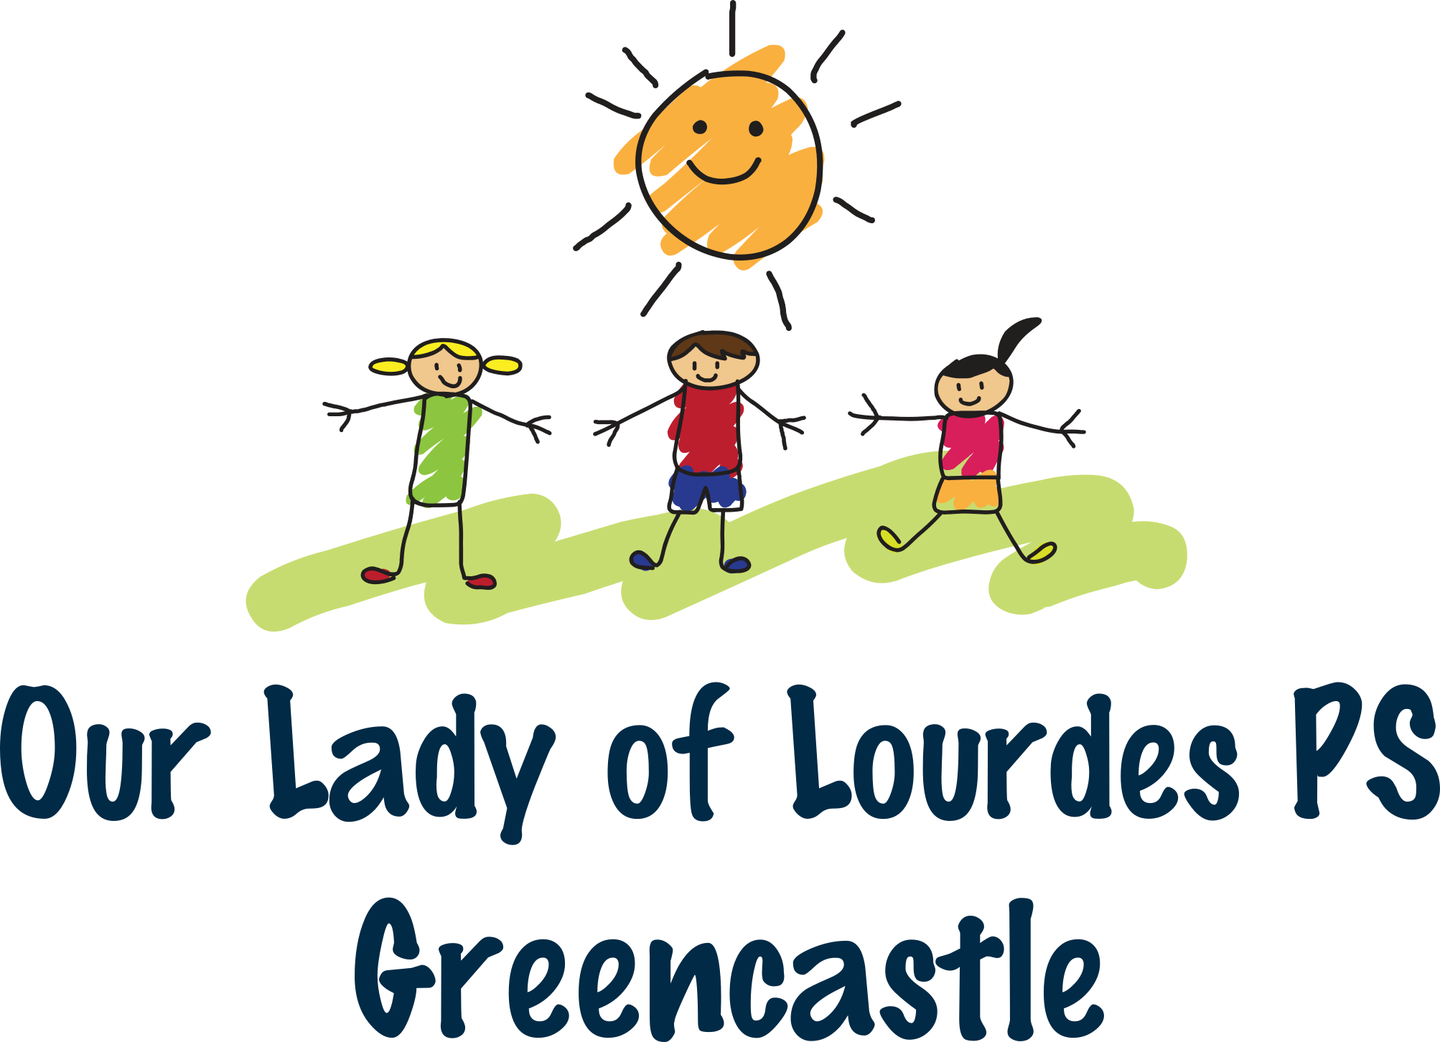

December Newsletter 2020
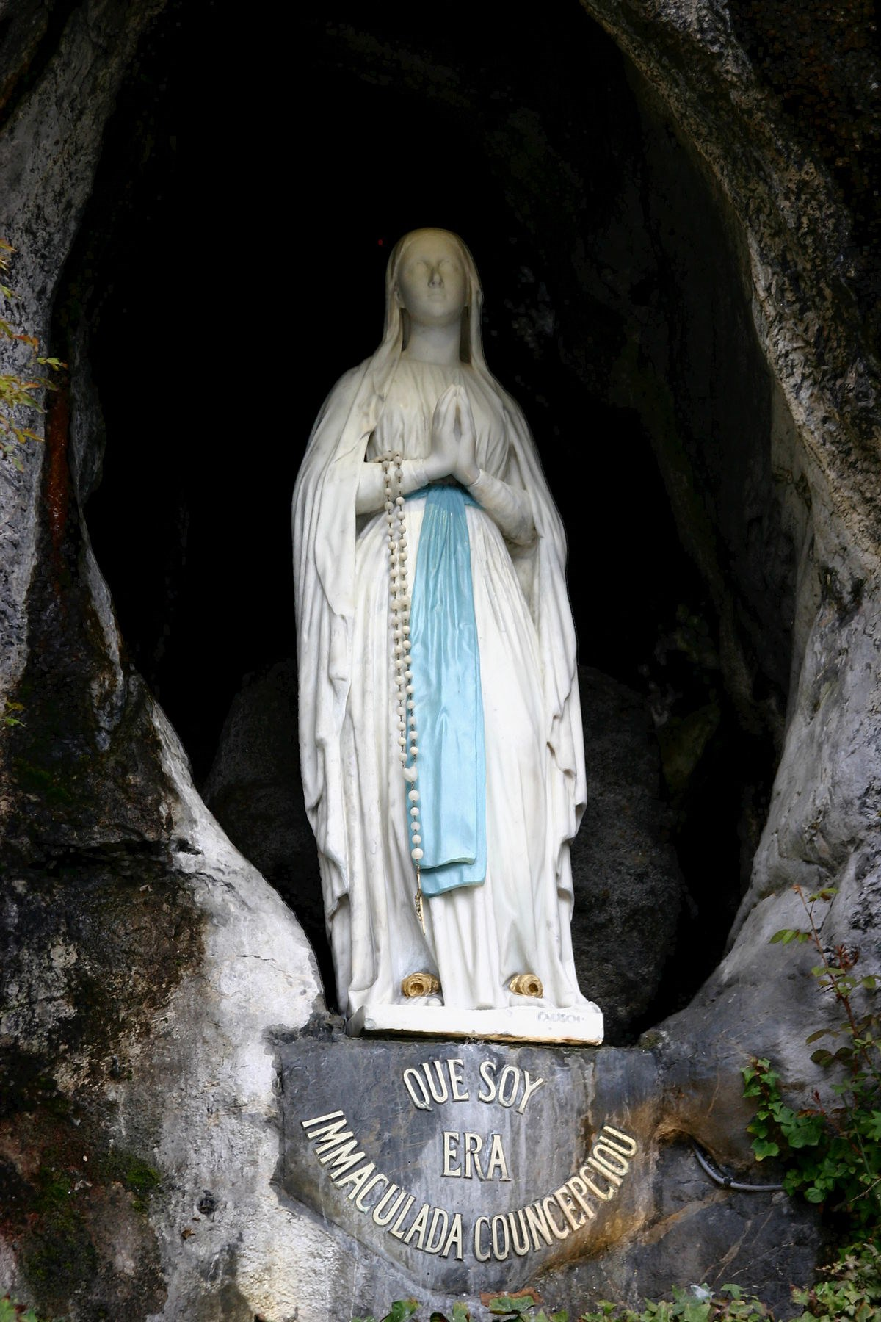
Principal:Mrs D Mc Cann
Contact :
279 Crockanboy Rd
Greencastle
BT79 7UR
028 81648732
dmccann396@c2kni.net

Christmas Countdown
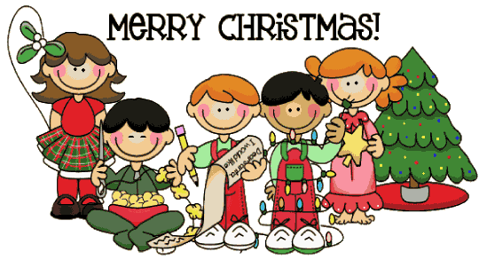
We have been very busy in school putting up our decorations and preparing for Christmas.
Our year 4/5 pupils have been learning about Advent. On the first Sunday, a purple candle (the candle of hope) was lit in preparation for the coming of Jesus at Christmas.
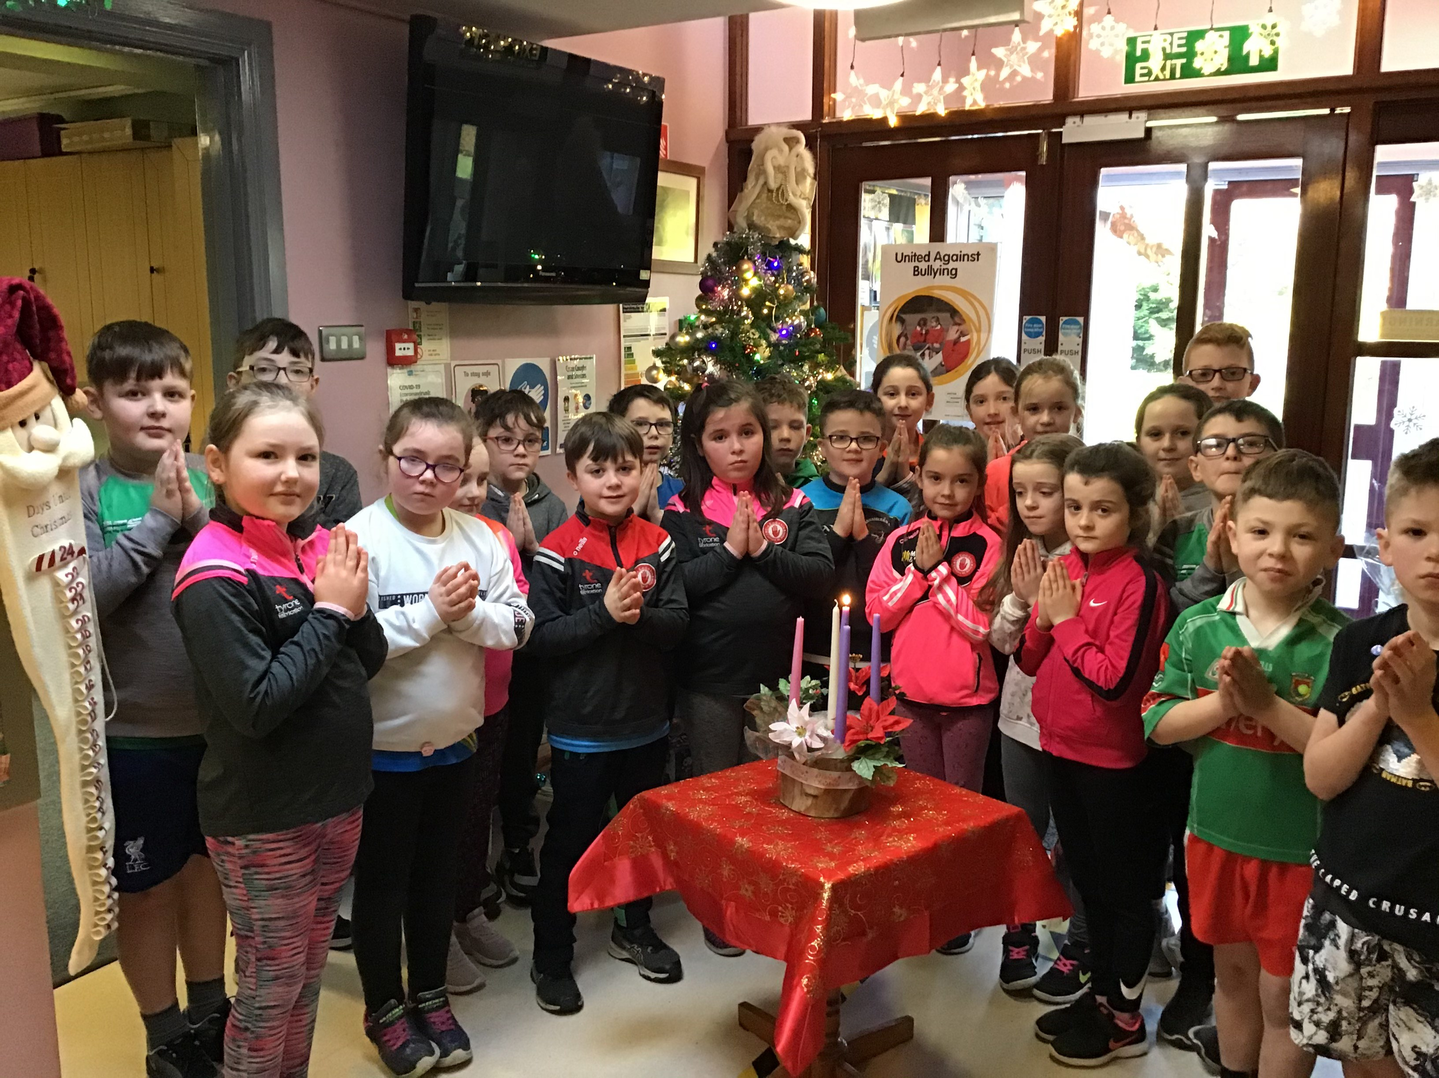

Christmas Presents
The staff have agreed this year, that parents, if they wish, can donate to our School Funds (to help purchase much needed reading books), in lieu of sending in staff Christmas presents. Thank you to all families who have already made a donation in these difficult times.
Christmas cards may be sent into school, they will be kept quarantined until the Christmas holidays. We will redistribute cards to each class then.
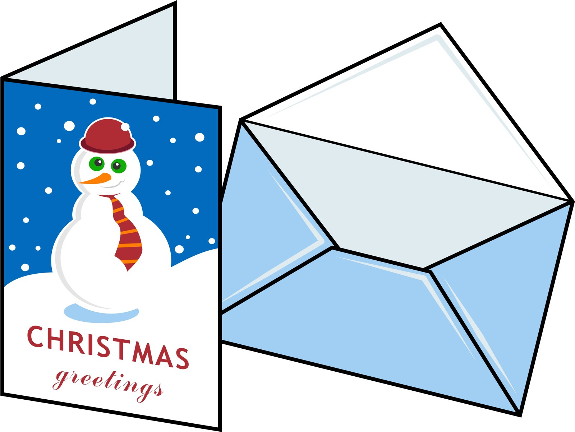

Christmas Dinner
We will be having Christmas dinner in school on Thursday 10th December. If your child would like to have Christmas dinner, we would ask that you notify the school before Monday 7th December. Pupils may wear their Christmas jumper to school that day. We look forward to seeing all the Christmas sparkle.
Christmas Dinner Menu
Roast Turkey
Stuffing
Cocktail Sausages
Roast/Creamed Potatoes
Vegetables

Festive Dessert
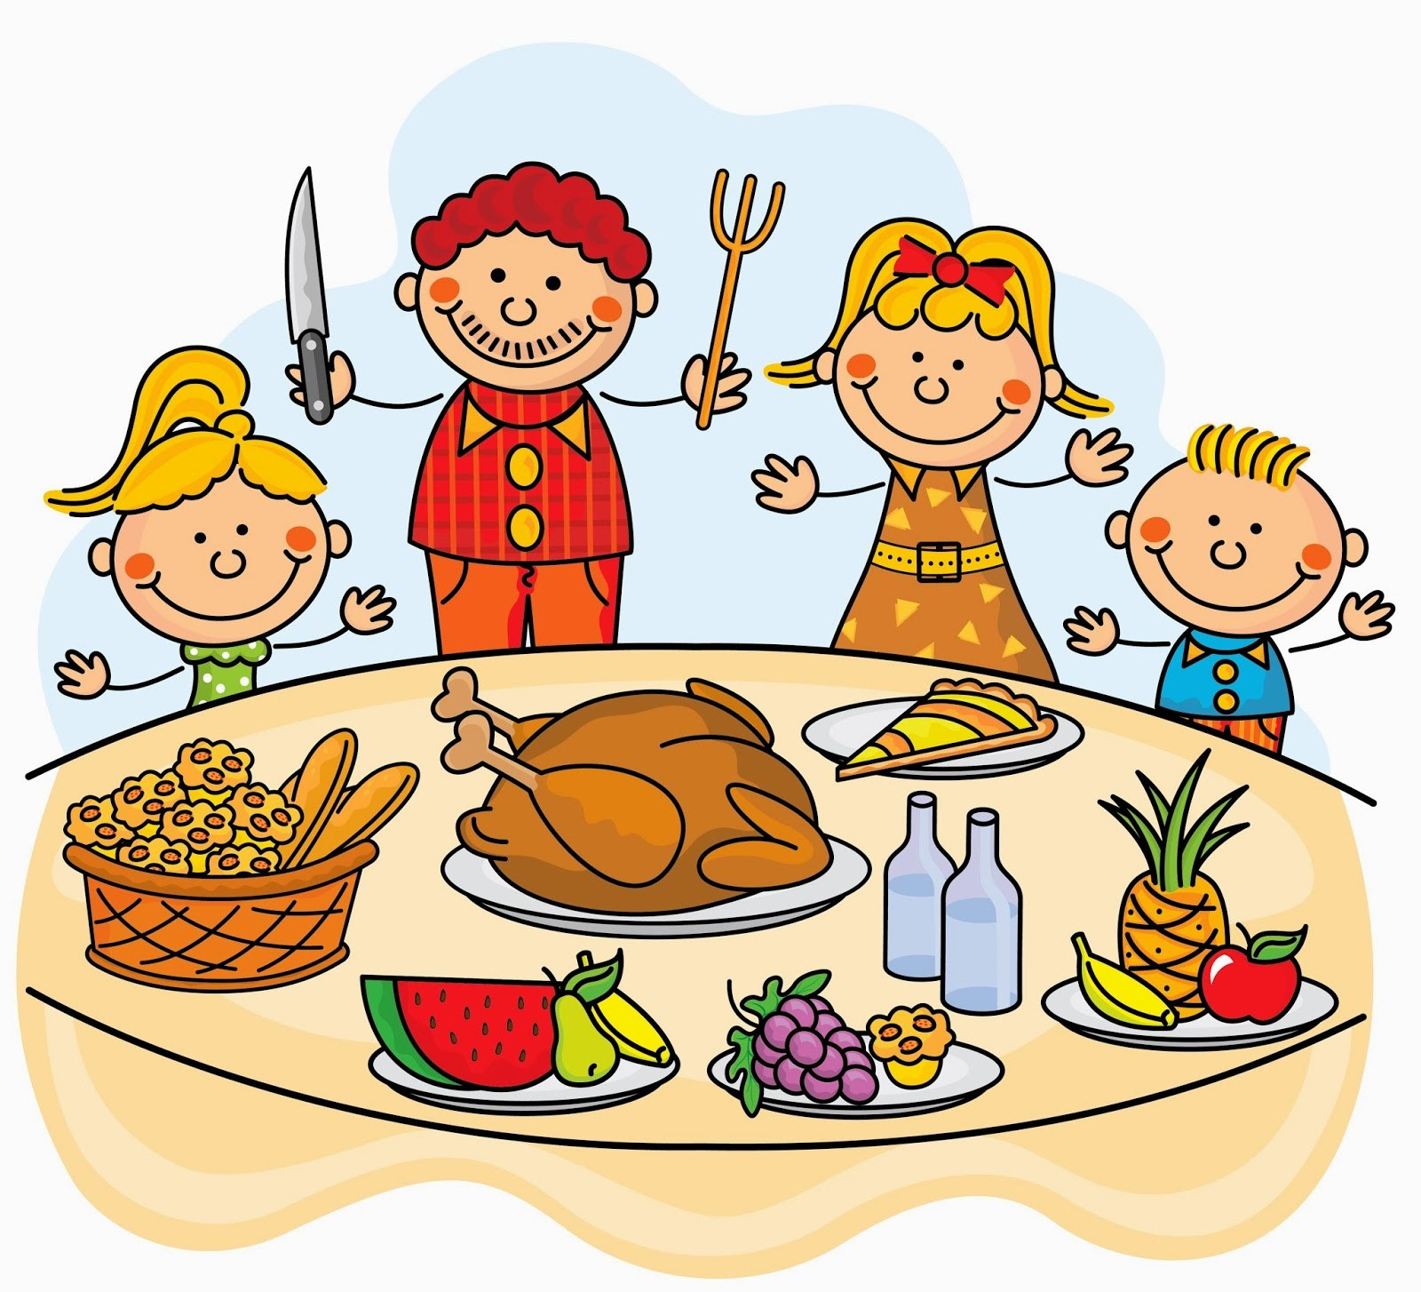

Christmas Show
Unfortunately, this year, we will be unable to invite parents and families into school to attend our School's Christmas Show. Instead we will be recording our show 'Cool Carols'. DVD's will be available to order from the school's office on the week beginning the 14th December. These will be priced at £10.00. Recording will take place on Wednesday the 9th December.
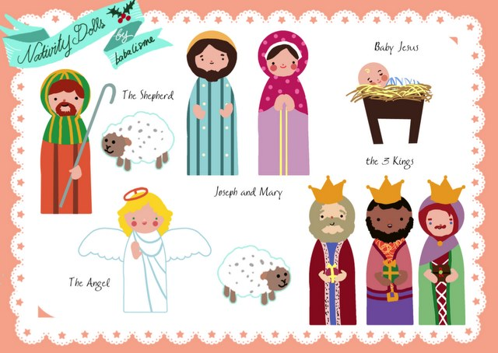

Annual Christmas Draw
Our Annual Christmas Draw will take place on Thursday 10th December. Heather our very creative classroom assistant kindly made four fabulous hampers for you to win. We also have many other prizes... including 3 months gym membership, a beautiful bodhran, fitness tracker and books for the kids to enjoy.
More tickets for the Christmas draw can be requested from the school office and class teacher. So far the uptake for tickets has been very encouraging. We would also like to thank those who donated prizes to our school draw. It is greatly appreciated.
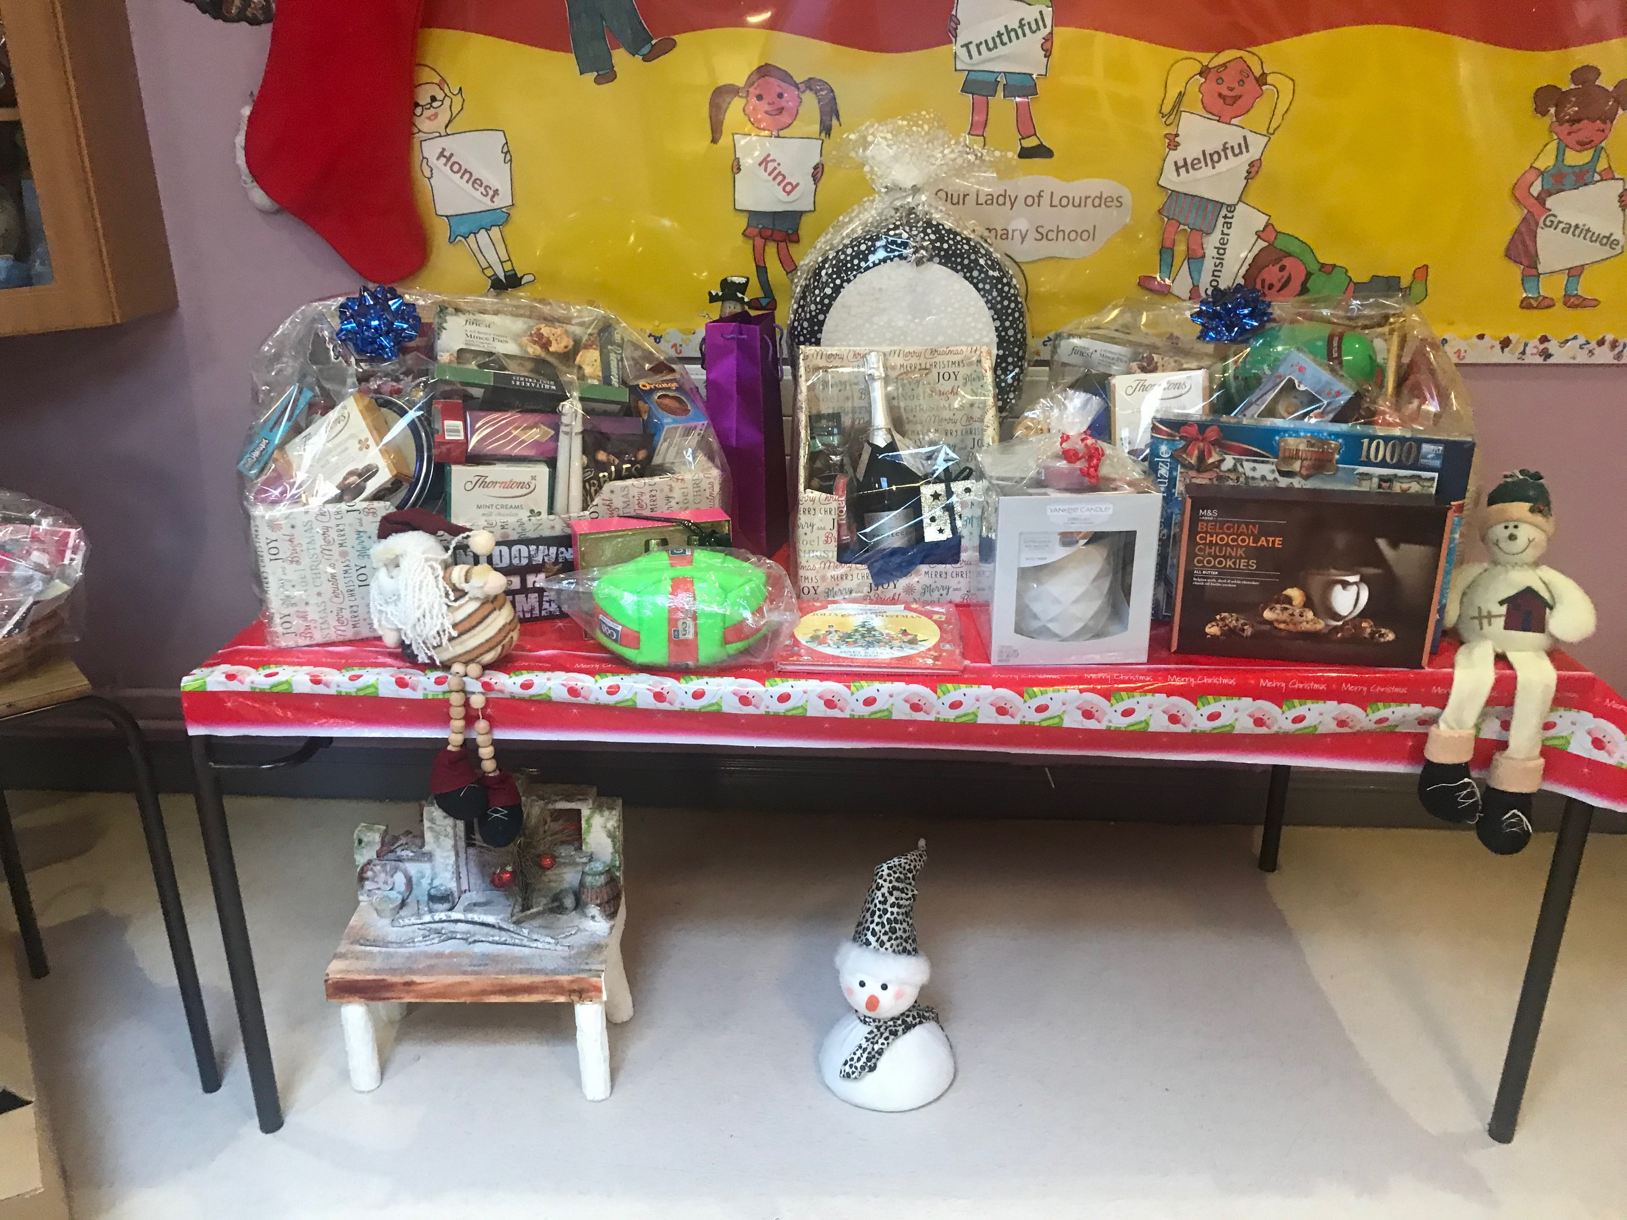
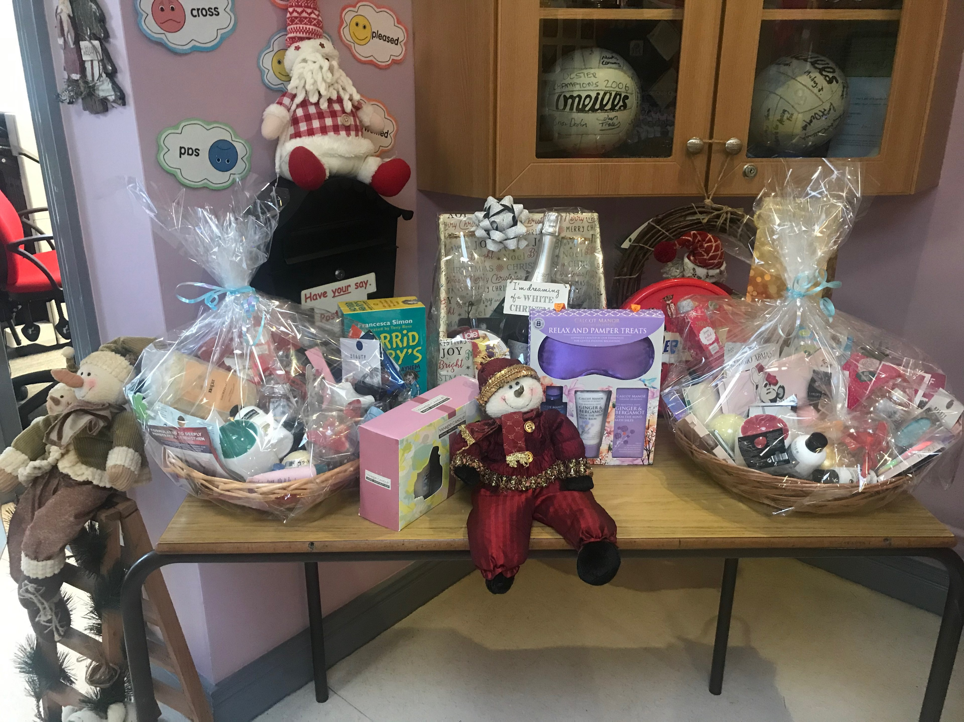
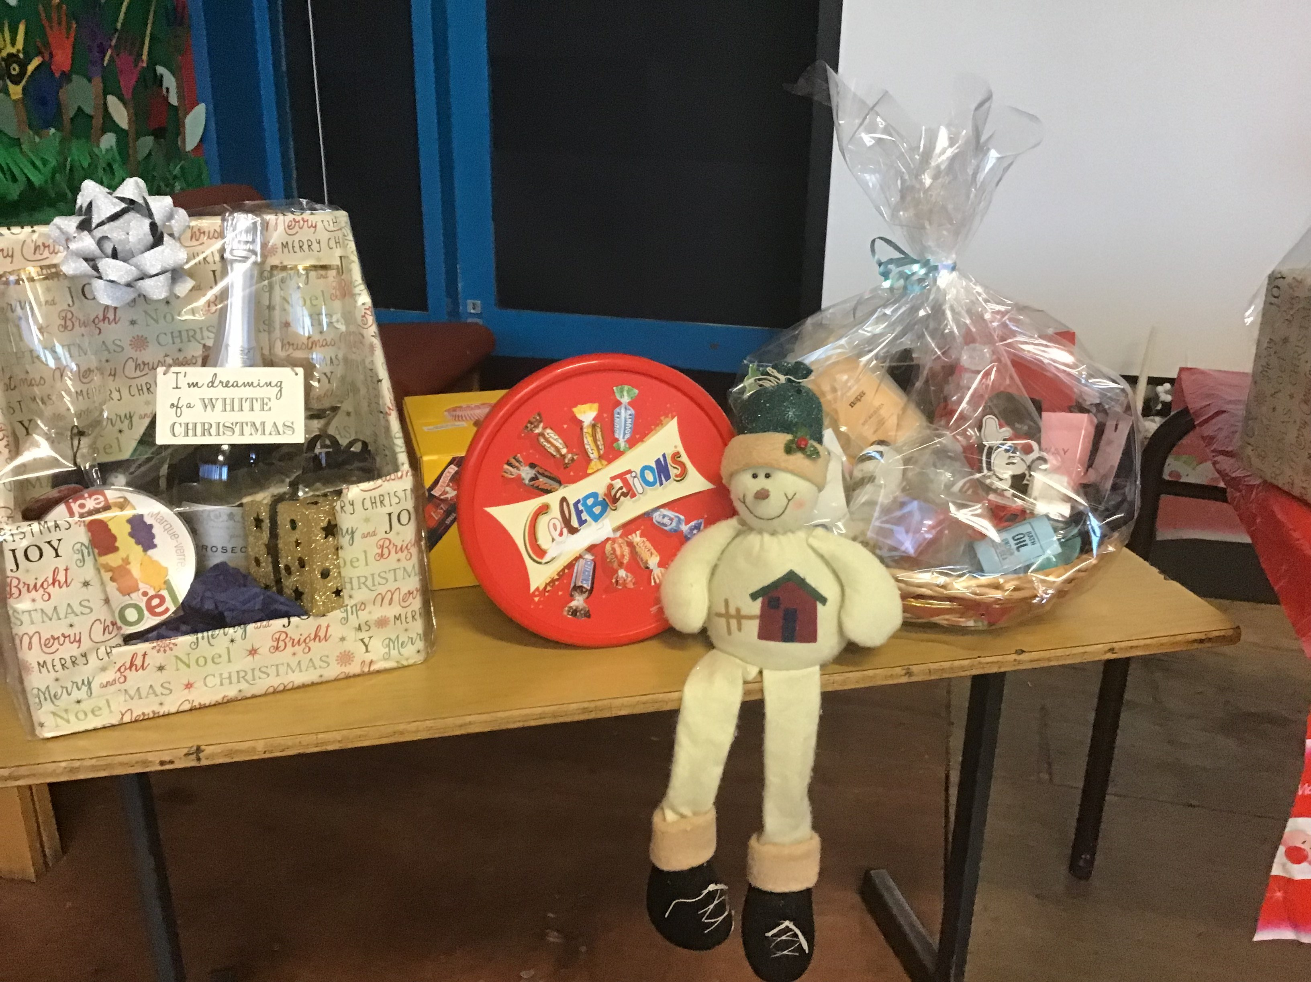

Eco Council Festive Xmas Logs
Our year 6/7 pupils have been busy making some lovely festive logs for sale. All funds will go towards our Outdoor classroom. Place your order by telephoning the school's office.
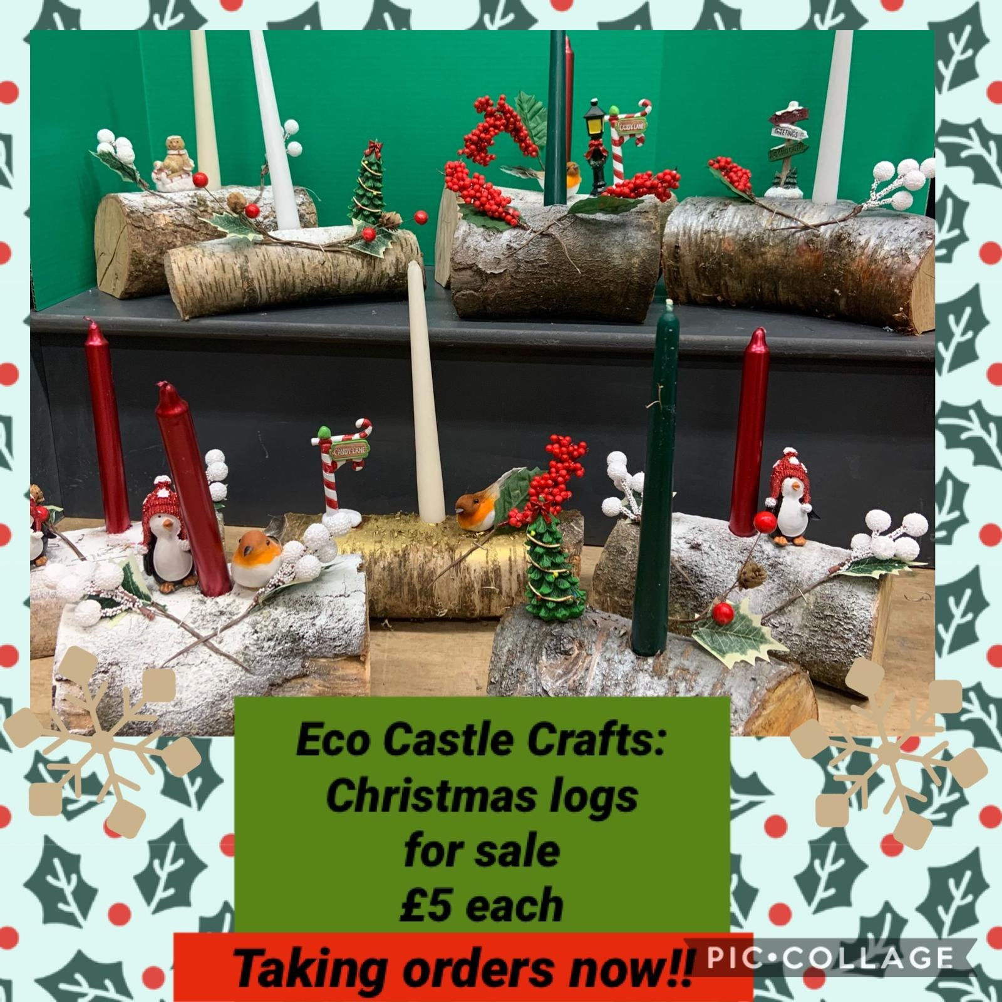

Accelerated Reader P4-P7
Our boys and girls have been reading hundreds of books since we came back to school after Halloween We have two more Millionaire Readers. Congratulations to Aimee Fox and Fianna Clarke in Year 6. The race is on to see who will be the next millionaire reader?

Millionaire Reader
Who will be the next Millionaire Reader?
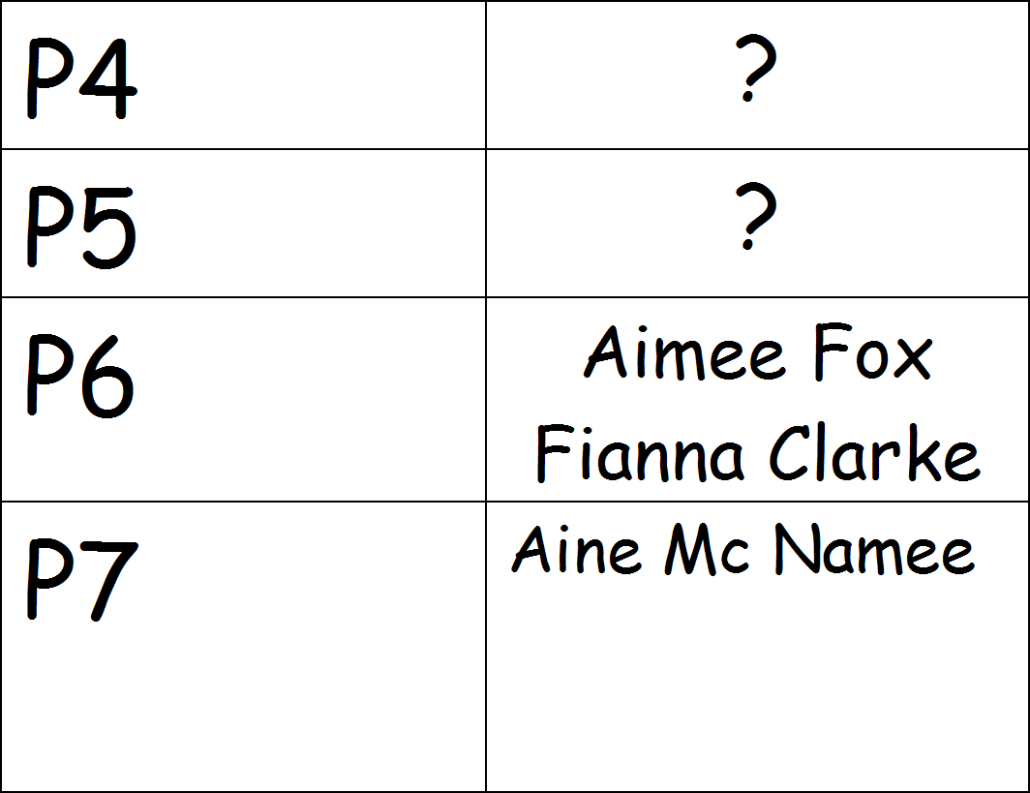
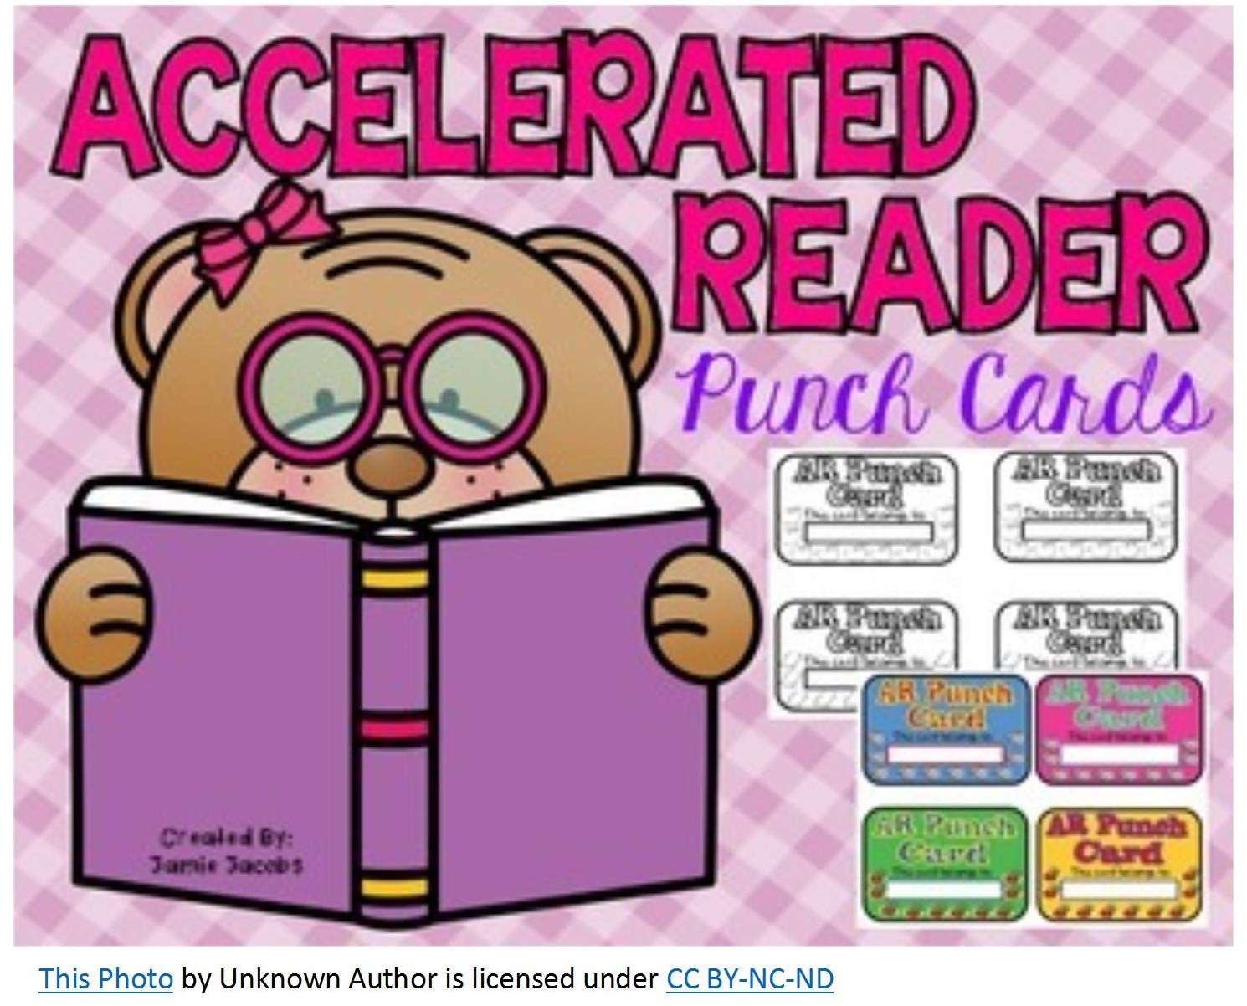

Holidays
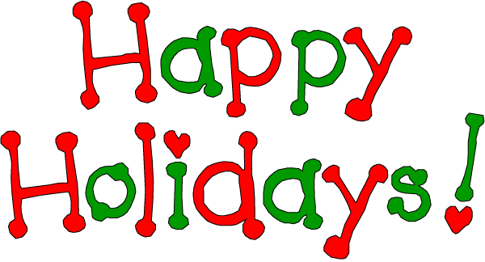
The last day in school will be Tuesday 22nd December. School will be closed Wednesday 23rd - Monday 4th January (inclusive). Your child will return to school on Tuesday 5th January. These arrangements may be subject to change, dependent on any impromptu announcements from the Department of Education/ NI Executive.

Dates to Remember
- Wednesday 9th December - Recording of our Christmas show.
- Thursday 10th December - Christmas Dinner and Jumper Day.
- Monday 14th December - Taking orders for Christmas DVD.
- Tuesday 22nd December - Christmas Holidays.

